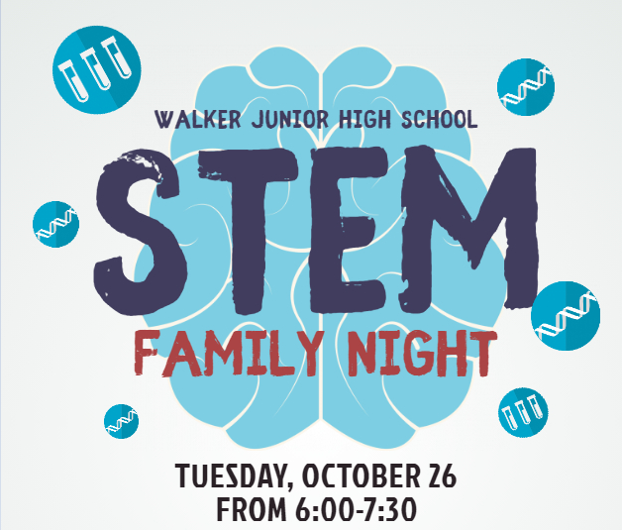
________________________________________________________________________________________________________________
- Fun science and math activities
- A robotics demonstration
- The Pegasus Unit van manned by former NASA flight training officer
- An outdoor performance by our own WAJH choir
- Drone demonstration
- Learn how math makes you better at baseball
- Book Fair
- Graphic design interactive (drawing pads and green screen)
- Food trucks
Come out to STEM Family Night for hands-on fun for the whole family including Science, Technology, Engineering, and Math demonstrations, activities, and speakers!!

Yes! Sign us up for Family STEM Night!
Last Name: _ Number of Adults:
Number of Children: Ages of Children:

Email:
** Please return to your ELA teacher by Friday, October 15

